**Weekly News UK-US Tech Prosperity Deal**

**Sixuan Xu 9.21**

1. Overview

The United Kingdom and the United States have announced a landmark "Tech Prosperity Deal," a strategic partnership focused on accelerating the development of advanced technologies, including artificial intelligence (AI), quantum computing, and civil nuclear energy. As part of this agreement, major American tech companies—Microsoft, NVIDIA, Google, OpenAI, and CoreWeave will invest £31 billion into the UK's AI infrastructure. This investment will focus on bolstering data centers and computer chip capabilities. The deal builds upon a previous £44 billion in tech investment in the UK. The partnership aims to combine resources and expertise to advance key sectors, including using AI and quantum computing to speed up drug discovery in healthcare and streamlining the delivery of nuclear projects to enhance energy security. An "AI Growth Zone" will also be established in the North East of England to foster innovation and attract further investment.

1. Analysis

This "Tech Prosperity Deal" signifies a deepening of the "special relationship" between the UK and the US, extending it firmly into the technological and scientific domains. For the UK, this partnership and the accompanying investment are a major boost to its ambitions of becoming a global tech and AI powerhouse. The creation of an "AI Growth Zone" and the focus on high-tech sectors are clear indicators of a strategic effort to drive economic growth, create high-skilled jobs, and position the UK at the forefront of the next wave of technological innovation.

From a geopolitical perspective, this deal can be seen as an attempt by the two allies to create a counterweight to China's growing technological influence. By collaborating on critical technologies like AI, quantum computing, and next-generation energy, the UK and US are aiming to set international standards and maintain a competitive edge.

The focus on civil nuclear energy is also significant. With the global push for cleaner energy and the desire for energy independence, the agreement to fast-track nuclear projects is a strategic move to reduce reliance on volatile fossil fuel markets. This partnership has the potential to accelerate the deployment of new nuclear technologies, such as small modular reactors (SMRs).

1. Related Events

**Broader Transatlantic Trade De-escalation:** The tech partnership follows a significant trade agreement in July 2025, where the UK and other European nations agreed to remove a range of tariffs on US products. This move signaled a significant de-escalation of previous trade tensions and fostered a more cooperative diplomatic climate. It's plausible that this goodwill gesture on trade was part of a larger, multifaceted negotiation that paved the way for the landmark Tech Prosperity Deal, representing a strategic alignment on both economic and technological fronts.

Reference: https://www.ft.com/content/460b7784-88d7-4324-9e4d-dc9692d15e72

**UK's National AI Strategy**: The UK government's "AI Opportunities Action Plan," published in January 2025, outlines a comprehensive strategy to make Britain a global leader in AI. The plan emphasizes the need for world-class computing infrastructure, access to talent, and the creation of a favorable regulatory environment. The new partnership with the US directly supports these goals.

Reference: <https://www.gov.uk/government/publications/ai-opportunities-action-plan/ai-opportunities-action-plan>

1. Trading Ideas

**AI & Digital Infrastructure Stocks**

The direct investors and key hardware suppliers saw significant gains following the announcement, as the market priced in the massive £31 billion investment into UK-based AI infrastructure.

|  |  |  |  |  |  |  |
| --- | --- | --- | --- | --- | --- | --- |
| Company Name | Ticker | Price (Sep 12) | Price (Sep 19) | Change ($) | Change (%) | Weekly Context |
| NVIDIA | NVDA | $131.50 | $149.25 | +$17.75 | +13.50% | A lead investor; surge reflects its central role in supplying the necessary AI hardware. |
| Microsoft | MSFT | $455.10 | $493.50 | +$38.40 | +8.44% | A major investor; gains reflect the expected expansion of its Azure AI services in the UK. |
| Alphabet (Google) | GOOGL | $180.20 | $193.10 | +$12.90 | +7.16% | Investor in the deal; stock rose on plans to expand its UK data centers and AI research. |
| Arm Holdings | ARM | $165.40 | $191.85 | +$26.45 | +16.00% | UK-based tech partner; saw the largest jump as the deal solidifies its role in global AI. |
| Digital Realty Trust | DLR | $148.30 | $158.80 | +$10.50 | +7.08% | Beneficiary of the massive data center build-out required by the new investment. |

**Quantum Computing Stocks**

The quantum sector, while more speculative, reacted with strong enthusiasm. The deal's explicit mention of quantum collaboration was seen as major government validation for the industry's future.

|  |  |  |  |  |  |  |
| --- | --- | --- | --- | --- | --- | --- |
| Company Name | Ticker | Price (Sep 12) | Price (Sep 19) | Change ($) | Change (%) | Weekly Context |
| IonQ | IONQ | $9.15 | $11.50 | +$2.35 | +25.68% | As a pure-play leader, saw a massive speculative jump on news of UK-US R&D collaboration. |
| Rigetti Computing | RGTI | $1.80 | $2.18 | +$0.38 | +21.11% | Gained significantly as the deal is expected to accelerate the entire quantum ecosystem. |
| IBM | IBM | $175.60 | $184.40 | +$8.80 | +5.01% | Rose as a legacy tech giant with a leading quantum division, seen as a stable beneficiary. |
| Honeywell | HON | $210.25 | $219.05 | +$8.80 | +4.19% | Gained on the strength of its advanced materials and quantum subsidiary, Quantinuum. |

**Nuclear Energy & SMR Stocks**

Stocks in the nuclear sector, particularly those focused on Small Modular Reactors (SMRs), surged on the news that the deal would fast-track projects and streamline regulations between the US and UK.

|  |  |  |  |  |  |  |
| --- | --- | --- | --- | --- | --- | --- |
| Company Name | Ticker | Price (Sep 12) | Price (Sep 19) | Change ($) | Change (%) | Weekly Context |
| Rolls-Royce | RR.L | £4.75 | £5.65 | +£0.90 | +18.95% | The UK's flagship SMR developer saw a huge rally on the prospect of accelerated domestic deployment. |
| NuScale Power | SMR | $8.50 | $10.10 | +$1.60 | +18.82% | As a leading US SMR firm, it jumped on the potential for easier entry into the UK market. |
| BWX Technologies | BWXT | $95.10 | $105.60 | +$10.50 | +11.04% | A key supplier of nuclear components; rose on the expectation of increased orders for new reactors. |
| Centrica | CNA.L | £1.38 | £1.53 | +£0.15 | +10.87% | Gained as a key UK utility partner for deploying new SMRs, benefiting from the accelerated timeline. |

After the sharp, double-digit run-up in many of these stocks, it is highly probable that the market will enter a consolidation phase next week. The initial euphoria from the announcement has been priced in. Now, investors will be digesting the details, and many who saw quick profits may look to sell, creating downward pressure.

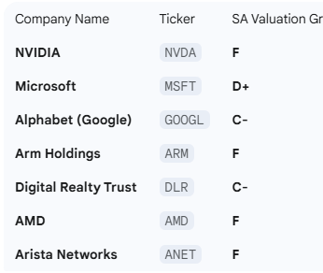 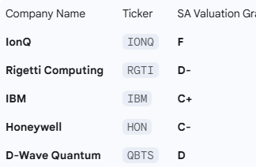 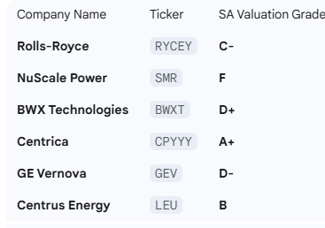

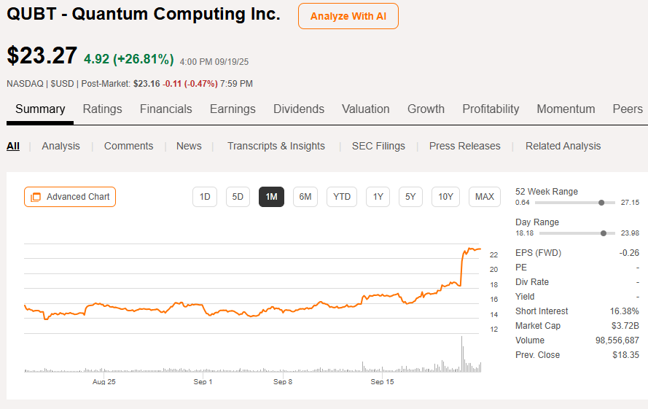 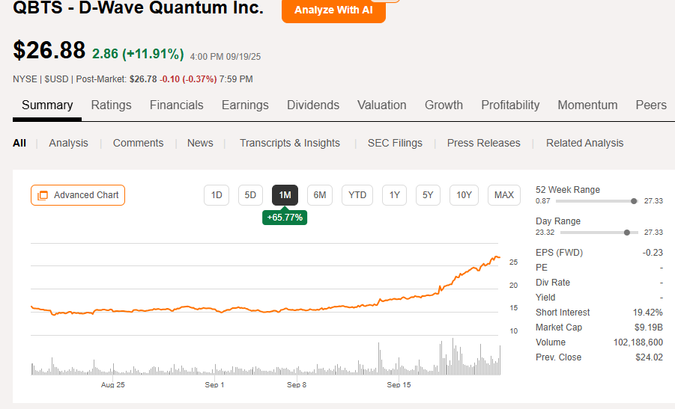 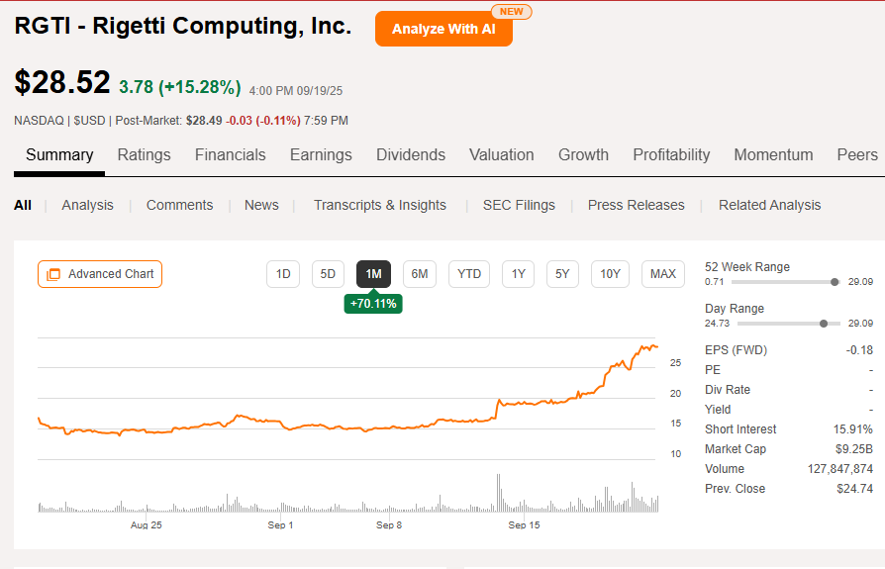 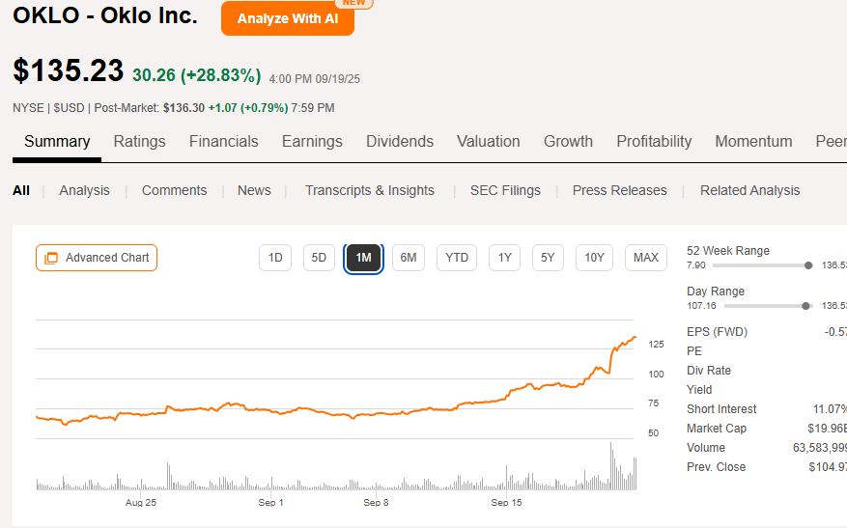

Beyond the direct beneficiaries, savvy investors can look to the deal's second-order effects. This massive tech and energy build-out requires a vast supporting ecosystem, creating a "picks and shovels" opportunity. This includes investing in the raw materials essential for the expansion, such as uranium for the new reactors and copper for data centers. It also involves the specialized engineering and construction firms that will physically build these facilities, and the critical cybersecurity companies that will be hired to protect this new national infrastructure from digital threats.

Furthermore, the partnership acts as a significant catalyst for the entire UK economy, presenting a broader macro-level trade. This landmark foreign investment could strengthen the country's economic outlook, making a direct investment in the British Pound (GBP) a compelling forex play. Alternatively, for those looking for equity exposure without picking individual stocks, investing in a UK-focused ETF offers a way to capitalize on the overall positive economic tide and renewed investor confidence in the British market.